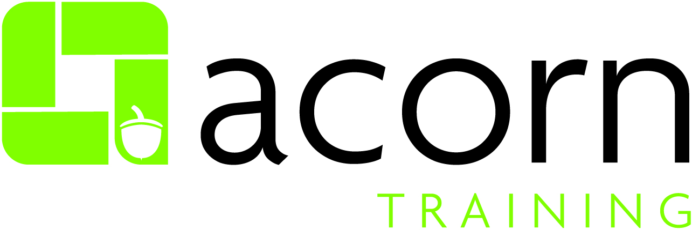

Equality and Diversity Policy

Purpose
Policy to commit to supporting, developing and promoting equality and diversity in all of its practices, activities and aims to establish an inclusive culture free from discrimination and based upon the values of dignity, courtesy and respect. Acorn Training will support and develop the staff and customers through providing all with access to facilities, personal and career development opportunities, employment and study on the basis of equality.
Key words
Equality, Diversity, Characteristics, Recruitment, Reporting
Document Control Number: | 13 – Equality and Diversity
Version: | 7
Date Adopted: | 10.10.17
Name of Owner: | Gareth Fallows
Title of Owner: | Managing Director
Name of Responsible Group: | Senior Management Team
Date issued for Publication: | October 2017
Expiry Date: | October 2022
Review Date: | October 2022
Target Audience: | All employees

Version Control
Version Number | Date | Comments  (Description change and amendments)
6 | 10.10.17 | Review of policy  Addition of notifying primes  New front cover and contents sheet  Removal of Footer  Added day to day responsibilities
7 | 17.09.18 | Consideration to gender pay gap  Equal pay statement added
7 | 25.11.2019 | Reviewed, no changes made
7 | 07.10.2020 | Reviewed, no changes made
8 | 01.11.2021 | Reviewed, no changes made

For more information contact: Sophia Franzen – Operations Director
Equality Statement – Due Regard
Acorn Training Ltd aims to design and implement policy documents that meet the diverse needs of our service, population and workforce, ensuring that none are placed at a disadvantage over others.
It takes into account the provisions of the Equality Act 2010 and promotes equal opportunities for all.
This document has been assessed to ensure that no one receives less favourable treatment on the protected characteristics of their age, disability, sex (gender), gender reassignment, sexual orientation, marriage and civil partnership, race, religion or belief, pregnancy and maternity.
In carrying out its functions, Acorn Training Ltd must have due regard to the different needs of different protected equality groups.
This applies to all the activities for which Acorn Training Ltd is responsible, including policy development and review.

Reporting to Prime Providers and Funding Bodies
Where appropriate, there may be the need to inform a prime provider of irregularities or specific issues within the remit and scope of this policy. At all times, this should be discussed with the Managing Director or the delegated officer. A non-conformity/incident report should be raised in line with our ISO9001 accredited quality management system to aid and facilitate reporting.
Individuals may also wish to refer to the whistle blowing process where it is not deemed appropriate to report to the Managing Director or their delegated officer.

Training
The following training is required to support implementation and ongoing maintenance of this policy:
- Updated policy document to be issued to all employees

EQUALITY AND DIVERSITY POLICY
Contents
- General Statement Policy | Page 5
- Legislation Background | Page 5
- Aims and Objectives | Page 7
- Definitions | Page 8
- Roles and Responsibilities | Page 8
- Application of the policy for staff | Page 10
- Application of the policy for customers | Page 11
- Training | Page 11
- Monitoring | Page 11
- Confidentiality | Page 11
- Breach of Policy | Page 12
- Reporting a complaint | Page 12
- Revision | Page 12

- General Policy Statement

Acorn Training is committed to supporting, developing and promoting equality and diversity in all of its practices and activities and aims to establish an inclusive culture free from discrimination and based upon the values of dignity, courtesy and respect. Acorn Training will support and develop the staff and customers through providing all with access to facilities, personal and career development opportunities, employment and study on the basis of equality.

Acorn Training is committed to eliminating discrimination and advancing equality on the grounds of age, disability, gender reassignment, marriage and civil partnership, pregnancy and maternity, race, religion and belief (including lack of belief), sex and sexual orientation and to fostering good relations between different groups.

This commitment supports the company’s principles and upholds the ethos of establishing a culture based on dignity, courtesy and respect.

This policy builds upon the foundation of equality legislation and anti-discrimination guidance and strives, not only to comply with legal requirements, but to use these to ensure that Acorn Training endeavours to exemplify best practice.

Acorn Training values diversity and recognises that the company is greatly enhanced by the disparate range of backgrounds, experiences, views, beliefs and cultures represented within its staff and customer populations. The company aims to embrace diversity in all of its activities and proudly acknowledges that variety and difference are intrinsic to the wellbeing and future development of the company.

The Equality and Diversity policy underpins the mission of Acorn Training to “provide a professional learning environment for everyone to succeed” and is integral to the success of the company as a provider and employer of choice.

This is an over-arching policy designed to outline the fundamental principles of Acorn Training’s commitment to equality and diversity and will be supported by specific equality policies and action plans.

The policy applies to all customers and applicants, to all applicants for posts with Acorn Training, to all staff employed on a full time or part-time basis, to all staff on permanent or temporary contracts, to agency staff, to honorary title/contract holders and visitors undertaking duties in the name of Acorn Training and to sub-contractors undertaking work on Acorn Training sites and all visitors to Acorn Training.

- Legislative Background

Acorn Training will abide by its current statutory requirements for all participants and employees, in line with its obligations under The Equality Act 2010. Acorn Training will work to ensure that all participants in the education process are aware of the moral and legal obligations upon them and take positive steps to ensure that no form of unlawful discrimination occurs.

There are nine protected characteristics:

- age
- disability
- gender reassignment,
- marriage and civil partnership
- pregnancy and maternity
- race
- religion or belief (including lack of belief)
- sex
- sexual orientation

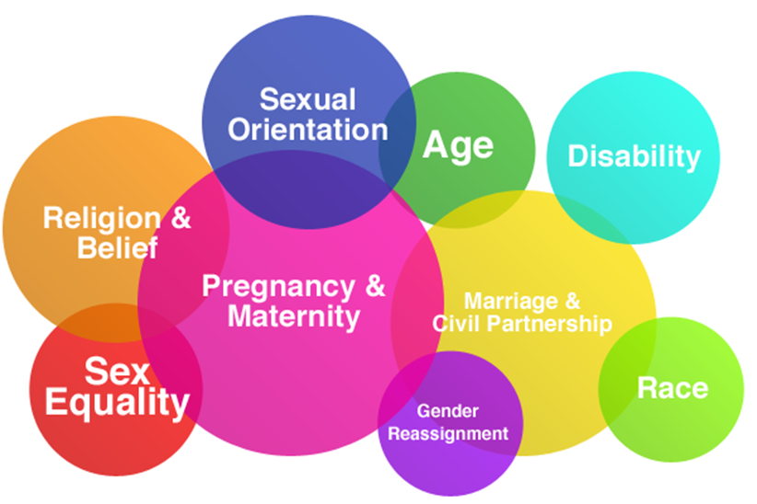

Under Equality legislation it is unlawful to

- Discriminate directly against anyone and treat him/her less favourably than others on the grounds of the protected characteristics of: age (unless this can be justified as a proportionate means of achieving a legitimate aim), disability (including discrimination arising from a disability and failure to make reasonable adjustments), gender reassignment, marriage and civil partnership, pregnancy and maternity, race, religion and belief (including lack of belief), sex and sexual orientation. This also includes discrimination based on perception of the person e.g. a belief that someone is gay or a belief that someone is disabled even if this is not actually true.
- Discriminate against someone for reasons relating to their association with a person on the grounds of the protected characteristics of age, disability, gender reassignment, race, religion or belief, sex and sexual orientation e.g. discriminating against an employee/student because they have a disabled dependant.

- Discriminate indirectly against anyone by applying a criterion, provision or practice which disadvantages people with a protected characteristic (age, disability, gender reassignment, marriage and civil partnership, race, religion and belief (including lack of belief), sex and sexual orientation) unless the person applying the provision can justify it as a proportionate means of achieving a legitimate aim.

- Subject someone to harassment for reasons relating to age, disability, gender reassignment, race, religion and belief (including lack of belief), sex and sexual orientation. This includes behaviour that an individual finds offensive on these grounds even if the behaviour is not directed at the individual. It is unlawful to treat a person less favourably because they either submit to, or reject, sexual harassment or harassment related to their sex.

- Victimise someone because s/he has made, or intends to make, a complaint or allegation or has given or intends to give evidence in relation to a complaint of discrimination in line with the Equality Act.

- Equal Pay
Acorn Training is committed to giving men and women equal treatment in the terms and conditions of their employment contract if they are employed to do:
- 'like work' - work that is the same or broadly similar
- work rated as equivalent under a job evaluation study
- work found to be of equal value in terms of effort, skill or decision making.

- Aims and Objectives

The aim of this policy is to ensure that in carrying out its activities AcornTraining will have due regard to,

- Eliminating unlawful discrimination, harassment and victimisation.

- Fostering good relations between people of a diverse background.

In the implementation of this policy Acorn Training’s objectives are to:

- develop and promote a culture of equality and diversity throughout the institution;

- develop and promote a culture of dignity, courtesy and respect;

- support all staff and customers, including provision of relevant support relating to age, disability, gender reassignment, marriage and civil partnership, pregnancy and maternity, race, religion and belief (including lack of belief), sex and sexual orientation.

- work to prevent all forms of unlawful discrimination;

- deal with all forms of discrimination consistently and effectively;

- ensure that the Equality and Diversity policy influences and informs the culture of Acorn Training.

- Definitions

Equal opportunities refers to the elimination of unlawful and unfair direct and indirect discrimination of particular groups and promoting equal access, treatment and outcomes that take into account specific needs of individuals.

Diversity encompasses visible and non-visible individual differences that includes, but is not limited to, differences protected by anti-discrimination legislation. Appreciating diversity is about valuing differences and recognising that everyone through their unique mixture of skills and experience has their own valuable contribution to make.

It is the aim of Acorn Training that individuals and groups within the company are not only treated on the basis of equality, but that their diverse contributions to the academic, social and cultural life of Acorn Training are recognised and developed.

- Roles and Responsibilities:

It is the responsibility of all members of staff and customers of Acorn Training behave with dignity, courtesy and respect and to act in a manner that does not unlawfully discriminate at all times.

Role of Staff

- Actively to encourage non-discriminatory practices and to report any incidences of behaviour that fail to comply with this policy.

- Support the aims of the Acorn Training Equality and Diversity policy;

- Undertake appropriate equality and diversity training.

Role of Customer

- Actively to encourage non-discriminatory practices and to report any incidences of behaviour that fail to comply with this policy.

- Support the aims of the Acorn Training Equality and Diversity policy.

- Be aware of equality and diversity issues.

Role of Human Resources

- Provide appropriate equality and diversity awareness and training for all staff.

- Support Senior Managers in implementing the policy.

- Ensure that recruitment advertising, selection and appointment procedures, performance management processes and disciplinary grievance processes are fair and transparent and are consistently applied.

- Monitor employment equality data and to publish the findings of monitoring activity, as appropriate.

Role of Senior Managers

- Ensure that all members of staff within Acorn Training receive the appropriate equality and diversity training.

- Investigate all matters of alleged discrimination, harassment and inappropriate behaviour promptly and thoroughly.

- Ensure that selection and appointment procedures, performance management processes, staff development opportunities and disciplinary and grievance processes are fairly and consistently applied to all staff.

- Treat all applications for flexible practices on a fair and equitable basis and to provide reasonable and objective reasons when such requests must be refused.

- Ensure that selection and admissions procedures, assessment processes, career development opportunities and disciplinary and complaints procedures are fairly and consistently applied to all customer.

- Ensure that equality and diversity issues are considered as part of the Acorn Training planning processes.

Role of Managing Director

- Provide leadership in the operation and implementation of the Equality and Diversity policy.

- Be accountable for the actions of Acorn Training in relation to this policy.

Role of Senior Management Team

- Encourage, foster and promote a culture of equality and diversity in the company.

- Ensure consistency of this policy with other policies and initiatives, making recommendations and providing advice on implementation of the policy.

Role of all staff

- Ensure that they work to promote equality and diversity as an integral part of the services they provide and the policies and procedures they both develop and apply.

- Application of the Policy: Staff

Recruitment and Selection

- Recruitment advertising will encourage applications from all sectors of the community reflecting Acorn Training’s commitment to equality and diversity.

- Recruitment advertising will appear in publications appropriate to the audience capable of producing the best candidates (subject to budget considerations).

- Job descriptions, person specifications and recruitment advertisements will be written on the basis of the essential and justifiable requirements of the position.

- shortlisting, appointment and rejection decisions will be transparent and justifiable and will be supported by written comments.

Grading and Promotion

- All grading and promotions criteria and procedures will be free from prejudice and must be applied equitably and consistently.

Staff Development

- All staff will have equal access to induction, personal and career development opportunities and facilities.

Performance Management

- Probation and appraisal procedures will be clear and transparent and will be applied fairly across all staff.

Discipline and Grievance

- Disciplinary and grievance procedures will be applied fairly and transparently for all staff.

- Allegations of discrimination, harassment or inappropriate behaviour will be dealt with under the appropriate disciplinary procedures for staff.

- Applications of the Policy: Customer

Recruitment, Selection and Admission

- All information contained in course information sheets, websites and other material used in the recruitment of customers should promote equality of opportunity and make reference to this policy.

- All staff involved in the recruitment, selection and admission of students will have an awareness of equality and diversity.

- Assessment

- Clear, consistent and transparent criteria for customer’s assessments and all assessments will take place on an equal opportunities basis.

Discipline and Student Complaints

- Discipline and customer complaints procedures will be applied fairly and transparently for all customers.

- Allegations of harassment or discrimination will be dealt with under this policy and customer code of conduct agreement.

- Training

Equality and diversity awareness raising and training will be mandatory for all staff. Information will be provided to all customers in order to raise awareness of equality and diversity and the contents of this policy.

- Monitoring

Statistics will be gathered to monitor equality across all aspects of Acorn Training processes and will be used to inform future practice.

- Confidentiality

Any information disclosed to Acorn Training in relation equality and diversity issues will be kept strictly confidential in accordance with legislative requirements.

- Breach of Policy

Contravention of the Equality and Diversity policy will be treated as a disciplinary matter and offenders will be dealt with under Acorn training’s staff disciplinary policies or the customer code of conduct agreement.

- Reporting a Complaint

All complaints relating to harassment and bullying will be dealt with using the Learner Bullying and Harassment Policy. If you have any concerns that you wish to report you can email the confidential HR email address HR@acorntraining.eu.

Further useful sources of information are listed below:

www.ucu.org.uk
www.equalityhumanrights.com
www.equalities.gov.uk
www.acas.org.uk

- Revision

This policy will be revised on a yearly basis or when relevant new legislation comes into place.

